# Experimental Report

## CP1N5-24721015 李鹏麒

# **所属内容：Experimental N5-C1-20241120**

# **完成部分说明：编写算法与代码、调试与测试、撰写实验报告**

**The programme language**: C language

**The programming platform**: Visual Studio Code

**Program function**:

(1)Find the position and the frequency(number) of two specific characters appearing in a string.(a function to input the string , another function to find the position and the frequency (number) of a specific character appearing in a string. )

(2)A program with three functions that print a string in three different types.

**Program algorithm**:(Specific code is in the folder)

1. First, declare the function used to enter the string and the function used to look for a specific character in the string, and then enter any string and get the result. The function used to enter the character string saves the input on the keyboard into the intermediate variable ch through the while loop statement and getchar() function, and then inputs the one-to-one input into the defined string str []. The function looking for location and frequency traverses the string content under the string length limit obtained by the strlen() function to get the result.
2. First, I declare the three custom functions to be used under the same main function, so that the three forms can be expressed within one main function. Use the "printf" (“%*.*s”, len, num, str) to control the output, the first * corresponds to len represents the length of the output string, if the value of len is greater than the actual length, the system will use the space to fill the blank, manifested as right alignment, the second * corresponds to num represents accuracy, determine the specific print length of str.

**Program flow chart:**

(1)

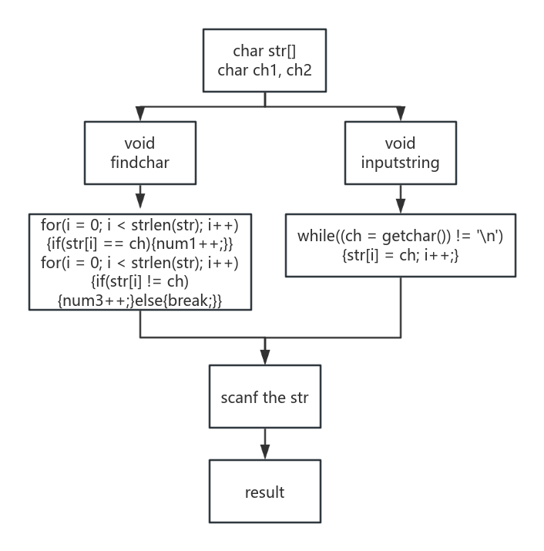

(2)

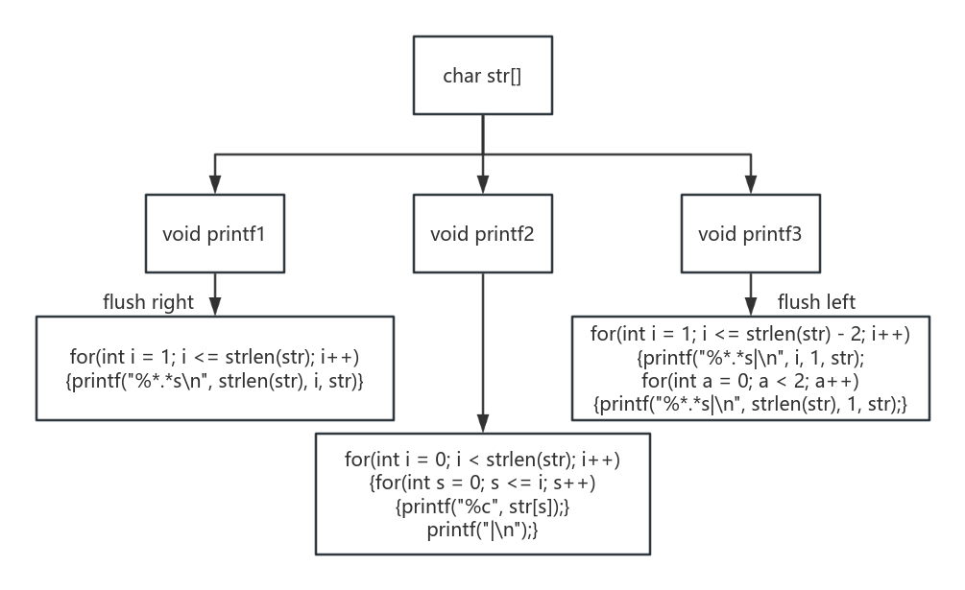

**Program experiment test:**

(1)

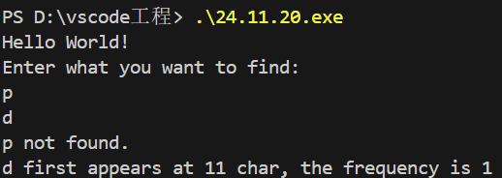

(2)

